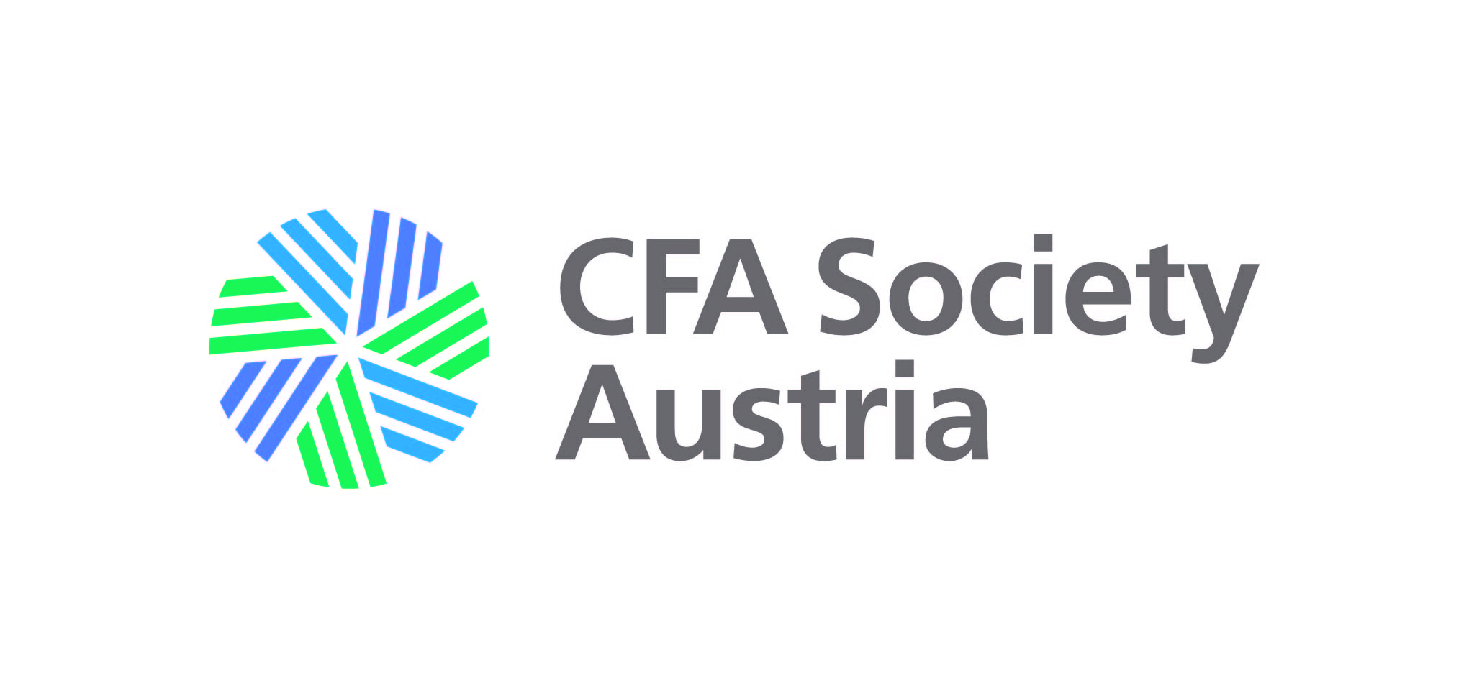
CFA SOCIETY AUSTRIA – Application for Affiliate Student Membership
First Name: ...........................................................................................................................

Last Name: ...........................................................................................................................

Address: …............................................................................................................................

E-Mail: ……............................................................................................................................

Phone: ……............................................................................................................................

Employer: ……......................................................................................................................

Address Employer: ..............................................................................................................

I confirm fulfilling one of the following criteria:

◻ having a sound reputation within the financial community
◻ being employed (resp. retired) in the financial industry
◻ being enrolled in the CFA Charter program.

Regular Dues:
- USD 100 (EUR 90) per year for applications between 01.07.2023 - 30.06.2024
- USD 50 (EUR 45) per half year for applications between 01.01.2024 - 30.06.2024

Student Dues:
- USD 50 (EUR 45) per year for applications between 01.07.2023 - 30.06.2024

CFA Society Austria
IBAN: AT42 2011 1845 7517 5900
Erste Bank und Sparkasse

Affiliate membership entitles to participate in all CFA Society Austria events.

Please send this application to:

Karin Reschenhofer, CFA
Treasurer
CFA Society Austria
Email: karin.reschenhofer@volksbankwien.at
www.cfaaustria.org/

..................................................................
Date, Signed

